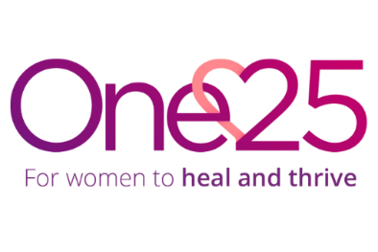
Job Description

Role: Services Manager
Reporting to: Operations Manager
Direct reports: Casework Team
Location: St Paul’s, Bristol

Job purpose: Work as part of a management team to oversee and develop the delivery of the Van Outreach, Casework and Health Hub, and support women to exit street sex work. The primary focus of this vacancy will be the health hub service. To provide leadership to the Casework Team, ensuring that they are well supported and that the team contributes to the wider organisational aims and uphold One25’s values.

Responsibilities:
- Recruit, induct, supervise, develop and manage a high functioning team to meet the needs of women in each service.
- Ensure quality and reputable services through the management of activities, caseloads, quality assurance, and effective recording and reporting.
- Ensure staff, service users and volunteers are safeguarded through adherence to policies, risk management plans and evaluation.
- Support the Operations Manager with strategic planning, reporting, partnerships, policy reviews and deputising where necessary as required.
- Any other duties that reasonably fall within the remit of the role, including participation in outreach shifts and on-call rota.

Personal Specification
- Experience managing or working in a similar service to the One25 casework service.
- Knowledge of the impact of street sex work and an understanding complex trauma
- Knowledge of housing and homelessness issues, physical and mental health issues, domestic violence & sexual violence and a good knowledge of services
- Knowledge, understanding and practical application of a range of evidence-based approaches (attachment theory, trauma informed approaches)
- Proven experience of managing / supervising teams, to deliver programmes of a high standard and to understand vicarious trauma and implement self-care.
- Ability to build strong relationships with partner agencies, influencing and advocating using evidence and practice to improve outcomes
- Strong understanding of and commitment to risk management, safeguarding and safety procedures.
- Confident and able to think on their feet and react decisively in pressurised situations
- Ability to manage change effectively and work proactively, strategically and flexibly to build and sustain ideas into effective programmes of work
- Highly organised and able to plan, manage and deliver multiple tasks, deadlines, and demands effectively.
- Proficient in Microsoft 365 and able to adapt to new IT and database systems
- Good understanding of boundaries and confidentiality, data protection and GDPR
- Excellent written and oral communication skills
- Strong attention to detail
- A genuine commitment to One25s values and to supporting marginalised women.
- Willingness to work outside usual hours occasionally.

