
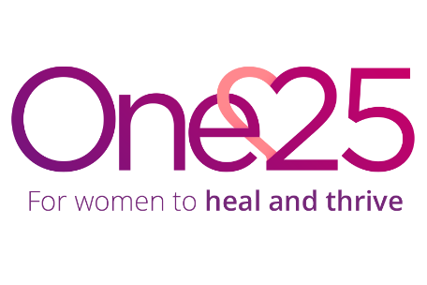
Job Description

Role: Recovery Caseworker (Female)
Reports to: Services Manager
Location: St Pauls, Bristol

Job purpose: Provide specialist support to women in street sex work to help them exit and address substance misuse. The Recovery Caseworker will deliver psychosocial treatment, connect women to clinical services, and use trauma-informed approaches to help women access One25 services and as a part of Bristol Horizons.

Job accountabilities:
- Provide casework support to women in street sex work via referrals from One25 and external partners.
- Deliver recovery support in community settings, meeting women where they are with assertive outreach.
- Complete needs and risk assessments, and create recovery plans based on women’s personal goals and risk management needs.
- Support access to drug treatment services including detox, scripting, and rehabilitation through Bristol Horizons.
- Deliver trauma-informed psychosocial interventions, harm reduction advice, and onward referrals to recovery services.
- Maintain accurate records, meet performance targets, and contribute to multi-agency team meeting, complex case meetings and clinical case meetings.
- Take part in One25’s night outreach van once a month and the On-Call rota every 6-8 weeks.
- Any other duties that reasonably fall within the remit of the role.

Person Specification:
- Knowledge and understanding of the nature and impact of addiction & substance misuse.
- Knowledge and understanding of the nature and impact of street sex work.
- Knowledge of adult safeguarding and child protection issues and legislation.
- Good understanding of boundaries and confidentiality, data protection and GDPR
- Understanding of risk and risk management, as it applies to substance misuse and complexity
- Demonstrable experience in working within health & social care, especially within a substance misuse treatment and recovery setting.
- Ability to work in multi-disciplinary teams, and to build strong relationships with partner agencies in order to influence and advocate for improved outcomes.
- Excellent written and oral communication skills and able to build and maintain positive, professional relationships internally and externally
- Proficient in use of database systems and Microsoft 365 (Word, Outlook, Excel, Teams).
- Highly organised and able to plan, manage and deliver multiple tasks, deadlines, and demands effectively.
- Flexible, pro-active with a can-do approach to problem-solving and working under pressure.
- Knowledge and understanding of person-centred and trauma-informed approaches.
- Understanding of vicarious trauma and self-care, and methods to reduce impact on self and team
- A genuine commitment to One25s values and to supporting marginalised women
- Willingness to work outside usual hours occasionally.

