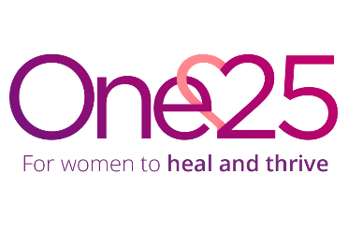
Job Description
Role: Co-production Coordinator
Reports to: Service Manager
Location: Office in St. Paul’s, Bristol

Job purpose: To support One25’s commitment to develop co-production opportunities and develop services with women who street sex work

Job accountabilities
- Develop and embed co-production opportunities within One25 to improve services for women who street sex work.
- To support the fortnightly meeting of Bridging Gaps, a group of women who have experienced multiple disadvantages that aim to improve trauma informed access to services.
- To support all members of Bridging Gaps, from their inductions to tailored 1:1 support for members which includes signposting to new opportunities for development.
- To link it with the co-production work happening in other organizations to guide best practice at One25.
- To feedback the work and impact of Bridging Gaps and other co-production opportunities across the organisation.

Person Specification
- Able and willing to operate in line with One25’s core values: Compassion – we care. Justice – we fight for change. Learning – we grow together.
- Understanding and passion for co-production and the benefits it brings.
- Understanding of complex trauma and the importance of trauma responsive services.
- Understanding of the experiences of women who street sex work.
- Good understanding of GDPR, data protection, boundaries and confidentiality
- High level of communication skills and able to connect with people who have their own unique experiences and backgrounds, as well as external partners.
- Confident in speaking to groups of people.
- Good numeracy and literacy skills.
- Proficient knowledge and ability in using IT systems including Microsoft 365 (Word, Outlook, Excel, PowerPoint, Teams) and confident in using case management systems.
- Excellent organisation skills, able to manage multiple priorities and projects.
- Flexible, pro-active with a can-do approach to problem-solving.
- Flexibility and willingness to work outside usual hours when required

