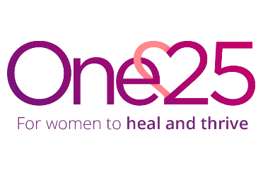
Job Description
Role: Supporter Development Manager
Reports to: Fundraising and Communications Manager (FCM)
Direct reports: Community Fundraiser, Fundraising and Engagement Officer, Fundraising and Communications Assistant
Location: Office in St. Pauls, Bristol, with homeworking options

Job purpose: To lead One25’s supporter development programme so that One25 can deliver high quality services to marginalised women.

Job accountabilities
- Income Generation: Develop and manage individual giving and community fundraising in line with One25’s strategy, targets, and priorities.
- Supporter Engagement: Lead stewardship efforts to nurture and maintain long-term supporter relationships.
- Team Leadership: Build and manage a high-performing team to achieve supporter engagement goals.
- Database and Reporting: Develop the supporter database for effective donor care, reporting, and strategic planning.
- Best Practice and Development: Stay informed on trends, identify opportunities, and improve individual giving programmes.
- Collaboration and Strategy: Support communications, fundraising initiatives, and strategic planning to maximise funding and engagement.
- Any other duties that reasonably fall within the remit of the role.

Person Specification
- Able and willing to operate in line with One25’s core values: Compassion – we care. Justice – we fight for change. Learning – we grow together.
- Knowledge of individual giving and community fundraising procedures and practices as well as the current landscape for donations and community fundraising.
- Proven experience securing donation income.
- Good understanding of GDPR, data protection, boundaries and confidentiality
- Understanding of the voluntary sector and working knowledge of charitable financial accounts and Gift Aid.
- Able to balance the needs concerns and priorities of others; handling opposition and conflict constructively
- Managing a high performing team to include planning and organising a programme of work, setting strategy and goals for self and others.
- Excellent communication skills and proven experience: able to generate enthusiasm and motivate others; to connect with people from all walks of life, backgrounds and cultures; and to develop and maintain relationships both within One25 and externally
- Excellent written communication skills, ensuring tone and language are tailored and appropriate for the audience, with experience of creative and informal writing for print and/or online audiences
- Good numeracy and analytical skills
- Proficient knowledge and ability in using IT systems including Microsoft 365 (Word, Outlook, Excel, PowerPoint, Teams) and experience of using fundraising software, databases and online tools (for example Donorfy, Raiser’s Edge, JustGiving).
- Excellent organisation skills, able to manage multiple priorities and projects.
- Flexible, pro-active with a can-do approach to problem-solving.
- Flexibility and willingness to work outside usual hours when required

