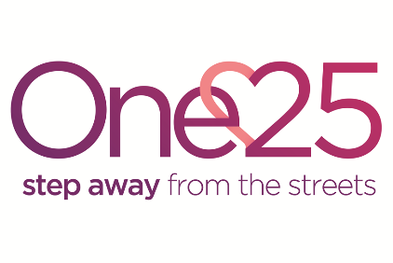
Chair of Trustees Application Form
If you need assistance completing this form, please telephone 0117 909 8832
Please give us your contact details
Title
First Name
Surname
Address
Postcode
Telephone
Email
Why are you interested in becoming One25s Chair of Trustees? (max 300 words)

What do you consider to be the primary functions and attributes of a good Chair? (max 300 words)

What skills and personal attributes do you have that make you a good candidate for this role? (max 300 words)

Please describe any experience you have of working as a chair of boards or subcommittees, in either the voluntary or business sector (max 300 words)

Please describe any experience you have of line managing a senior manager or of organisational management (max 300 words)
Do you have any special requirements to enable you to attend and contribute fully at One25 trustee board meetings?

Please provide details of referees we can contact to comment on your suitability to be Chair of Trustees for One25. These can be colleagues or friends but not family members.
Referee One | Referee Two
Name: | Name:
Address: | Address:
Email: | Email:
Telephone: | Telephone:
How do you know this person? | How do you know this person?

Declaration
I declare that:
I am over 18 years of age
I am not an undischarged bankrupt
I have not previously been removed from trusteeship of a charity by a court of the Charity
Commission
I am not under a disqualification order under the Company Directors’ Disqualification Act 1986
I am, in light of the above, not disqualified by the Charities Act 1993 (section 72) from acting as a charity trustee
I agree to declare any conflicts of interest which may be either –
A potential or measurable benefit either directly to myself or indirectly through a connected person; or where my duty to One25 may compete with a duty or loyalty I owe to another organisation or person (please see One25’s Conflict of Interest Policy for further information).
It is a criminal offence for a disqualified person to act as a trustee
I give permission for One25 Limited to retain any relevant data about me (including relevant sensitive data) that is received verbally or in writing or is kept in electronic form, on the understanding that it will only be used or disclosed in connection with the work of One25 Limited or at my specific written request: e.g. for a reference.
I certify that the above information contained in this application form is correct.

Signature: Date:

Please return this form and a current CV by email to Pat.Douglas@one25.org.uk
Or by post to
Pat Douglas, Company Secretary
One25 Ltd
138A Grosvenor Road
St Pauls
Bristol
BS2 8YA

