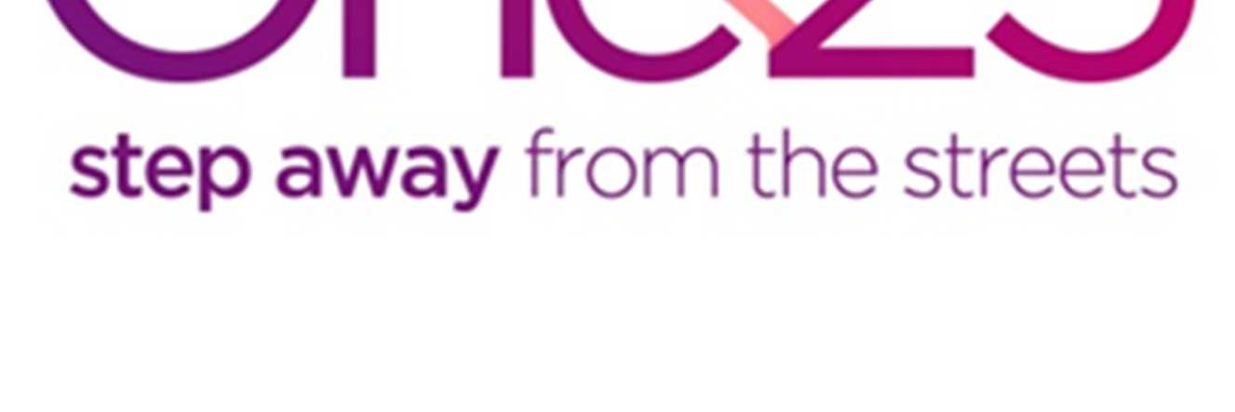
Golden Key Service Coordinator (Female)
2 Year Contract
Do you want to be part of a pro-active service supporting women who are trapped in street sex work? Are you passionate about supporting some of Bristol’s most vulnerable women to make positive changes in their lives?

Second Step is the lead agency in a partnership of organisations, including One25, chosen by the Big Lottery to deliver the Golden Key programme in Bristol to support people with multiple and complex needs relating to homelessness, mental health, drug and alcohol problems and offending. The programme’s aim is to find new ways to deliver services to a group of people who traditionally find it difficult to access services. The focus of the programme is on achieving a lasting impact through cultural and system change.

One25 is a Bristol based, registered charity (no.1062391) with a Christian ethos providing services for women trapped in street sex-work and those who are building positive new lives away from the streets.

Role description
To engage and support women with multiple disadvantages in leading their journeys, and to maximise their choice and control over the support they receive.

Working, with Golden Key and other agencies, to identify and help challenge blocks in the system, find creative solutions for clients, share learning and help influence change in the way agencies provide services for the client group.

To participate in the Golden Key approach to ‘action learning’ and help influence change in the way services are designed and delivered in future. To be part of a team developing a range of research and learning activities focused on building long term sustainable changes to the systems that support clients with multiple disadvantages.

It is an Occupational Requirement that applications for this post are open to women only, as permitted under Schedule 9, Part 1, of the Equality Act 2010. Enhanced DBS check will be required.

Hours: 37.5 hours per week Monday to Friday (including occasional evening commitments for which time off in lieu will be given)

Salary: £27,947

Benefits: Generous leave (33 days including bank holidays) plus up to 13 additional days’ time off in lieu; flexible working hours; and great job satisfaction

Closing Date: Monday 2 December 2019, 9am

Interviews: Monday 9 December 2019

Expected Start Date: As soon as possible

For further details and an application form Email: jobs@one25.org.uk or Tel: 0117 909 4387

