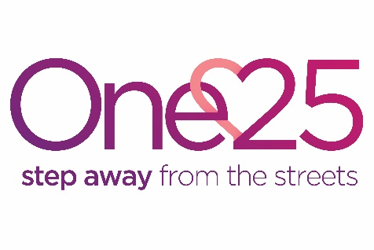

Pause Bristol Practice Lead – Permanent
Are you a creative and influential leader or practitioner who is passionate about improving the lives of vulnerable women and reducing the number of children being removed into care by supporting women to bring about change in their lives?
One25 is a leading charity in Bristol, set up to support women who street sex work to step away from a life on the streets. One25 hosts Pause Bristol, which is now an integral part of our service in its third year of operation. Pause is a national independent organisation seeking to prevent the damaging consequences of thousands more children being taken into care each year by working with women who have experienced, or are at risk of, repeated pregnancies that result in children needing to be removed from their care. The programme gives women the chance to pause and take control over their lives, breaking a destructive cycle that causes both them and their children deep trauma, as well as reducing huge costs to society and the taxpayer. Pause has set up programmes around the country and there is a profound need for Pause in Bristol.
Practice Lead Role
As a Pause Bristol Practice Lead you will provide leadership to this exciting core programme to ensure the implementation and delivery of an integrated package of health, therapeutic and social support. You will lead a team of five, working flexibly and collaboratively to improve outcomes for vulnerable and marginalised women. You will be passionate about changing entrenched social issues, and will respond by ‘doing things differently’.
We particularly encourage applications from Black, Asian and Minority Ethnic (BAME) candidates, as these groups are underrepresented in our workforce.
For more information please see one25.org.uk/get-involved/jobs/ or tel: 0117 909 8832.
Benefits: Generous leave (33 days including bank holidays) plus up to 13 additional days’ time off in lieu; flexible working hours; and great job satisfaction.
Hours: 37.5 hours a week over 5 days (including occasional evening and weekend commitments)
Salary: £30,000 - £32,000 per year
Contract: Permanent
Applications by: 9am, Monday 25 November 2019
Interviews: Thursday 5 December 2019
Expected start date: As soon as possible

